DPP Enrollment ESB Spec version 1.2 | 

*** Begin of SAP R4C changes for DLA ***
All Changes for R4C DLA highlighted in Turquoise.
*** Begin of SAP R5 changes for DPP ***
All Changes for R5 DPP highlighted in yellow

REVIEWER(S)
Name | Title | Department | Reviewed (date/time)
Manoj Ajgaonkar | SAP Solution Architect | SAP |  | <Date / Time>
Jack Hobbick | Testing Solution Manager | Smart Energy Program |  | <Date / Time>
Santhosh Shetty | Testing Lead | HCL |  | <Date / Time>
Jessica Scott | Audit Controls, Deloitte | Deloitte |  | <Date / Time>
Clark Oeler | Audit Controls, Deloitte | Deloitte |  | <Date / Time>
Chaitanya Kodela | BTS SDM Solution Architect | BTS |  | <Date / Time>
Nancy Pierce | Business Support Consultant | Virtual Contact Center |  | <Date / Time>
Abhishek Bansal | SAP Solution Architect | SAP |  | <Date / Time>
Ramesh Swarna | HCL Technical Lead | HCL |  | <Date / Time>
Nilabja Guha | ESB Team Lead | CAP |  | <Date / Time>
John Lalicker | ESB Team | CAP |  | <Date / Time>
Alok Bedi | Grid Director | CAP |  | <Date / Time>
Brent Kassing | iFactor Lead | iFactor |  | <Date / Time>
Jason Iaccio | iFactor Team | iFactor |  | <Date / Time>
Craig Bialy | DRMS Lead | Lockheed Martin |  | <Date / Time>

APPROVER(S)
Name | Title | Department | Approval (date/time)
Clay Engel | Enrollment Vendor Program Manager | Smart Energy Program | <Date / Time>
Elody Samuelson | DPP Program Manager | Smart Energy Program | <Date / Time>
Scott Tingle | SE Project Lead | Smart Energy Program | <Date / Time>
Krishna Karunakaram | Smart Energy Project Manager | Smart Energy Program | <Date / Time>
Jeff Yankley | IT-C&APS-IT App Portfolio-Front Office | BTS | <Date / Time>
Zach Pakkala | Business Support Consultant | Customer Operations/SE CORE | Abstained
Blair Estep | CE Release Manager | Smart Energy Program | <Date / Time>

CONTRIBUTORS
Name | Organization | Area of Contribution
Sudipto Sinha | Capgemini
Matthew C. Parker | CE

VERSION HISTORY
Version | Date | Author(s) | Revision Notes
1.0 | 09/25/2014 | Corey Ritts | Initial version
1.1 | 01/15/2015 | William Willis | Update for DIV and DRMS
1.2 | 07/16/2015 | Sudipto Sinha | Update for R5 DPP enrollment to update DPP enrollment Vendor and DRMS
1.2 | 09/23/2015 | Ashish Bhargava | Incorporate review comments.

Table of Contents

REVIEWER(S) 2
APPROVER(S) 2
1 OBJECT REQUIREMENT SUMMARY 5
1.1 Object Information and Attributes 5
1.2 Requirements Summary and Business Driver 5
1.3 Assumptions 7
1.4 Current Functionality 7
1.5 Required Functionality 8
1.6 Project / Development Constraints 15
1.7 Performance Criteria 15
1.8 Other Objects Affected 15
1.9 External References 16
1.10 Definitions/Acronyms/Abbreviations 16
1.11 Detail Requirements: 17
1.2 Architecture Specifications 22
1.3 Proposed Interface Usage Pattern 23
1.4 Architecture Principles 23
1.5 Error Handling 23
1.6 Post Execution Notification Details 26
1.7 Process Log Details 26
2 ADDITIONAL INFORMATION 27
2.1 Unit Test Plan 27
2.2 Information Security 29
2.3 Audit / Control 32
2.4 Questions / Issues / Risks 33

OBJECT REQUIREMENT SUMMARY

Object Information and Attributes

The following is current information about this object and document:
Object ID | CS_INT_MD_001
Title | Business Master Data
Team Which Owns the Object | Customer care/SEOC
System Version (SAP & Legacy) | SAP ISU ECC 6.0 EHP 6.0
Development Type | Interface
Priority | Medium
Estimated Complexity | Medium
Link to Process Flow | N/A
Association to Source SAP Interface Functional Specification | This is the source Interface.
Association to Destination SAP Interface Functional Specification | N/A
FTM Team Validation Required | Mark this as “Yes” or “No” if FTM Process Team has to validate the follow-on financial process (triggers a financial process) in SAP during Unit Test of this Object  Yes No

Requirements Summary and Business Driver

Opower is the existing customer portal and it is being replaced by Silver Springs Network portal (IWP). Opower is currently linked into the Consumers Enegry Portal to display customer consumption information. Opower is now being replaced by Silver Springs Network portal. This new portal (IWP) will be used to display customer information to the user. The customer will log into the Interval Web Portal and SAP will provide the customer with their business master data. Their BMD will be displayed on the home page for the customer to view.

The Business master data (BMD) interface is needed to send BMD to ESB. Once the data is in ESB, ESB will convert the data to the proper format for whichever system needs the BMD. The new interface will have a one time sync with ESB and then will execute a nightly batch run to provide updated/new BMD to ESB.

For R4C, BMD is required for the implementation of the Direct Load Administration (DLA) program. The DLA program is to provide a method of demand-side grid load shedding by means of one or more on/off switches installed on the load side of a customer’s premise, between an air conditioning unit(s) and the AMI meter. These switches can then be remotely activated by Consumer’s to control A/C load shedding, as per the customer’s contractual agreement and the need for a particular grid load-shedding event. SAP is the system of record for Customer Master Data. Accordingly, it is the source system for both DIV and DRMS, other components of the DLA program along with the Advanced Metering System (AMS). The DIV and DRMS need BMD in order to fulfill their roles in the program. ESB will provide the daily BMD data extracts that they will need to fulfill their roles in the program.

For Release 5, BMD is required for the implementation of the Dynamic Peak Program(DPP). The DPP program is being designed to encourage customer to reduce their load during the critical events (CPP and PTR), and hence enjoy savings on their monthly electricity bill. SAP is the system of record for Customer Master Data and all the DPP enrollments. The Enrollment vendor and DRMS need BMD in order to fulfill their roles in the program. ESB will provide the daily BMD data extracts that they will need to fulfill their roles in the program.

This interface will be used for below purposes
For DPP Enrollment Vendor (EV)
- To do the initial load of customer information to Enrollment vendor for marketing to DPP customer.
- To do daily delta uploads for any business master data changes in SAP system
- Enrollment Pending updates for CE initiated enrollments
- Enrollment Confirmation for EV and CE initiated enrollments
- De-Enrollment Confirmation for EV and CE initiated de-enrollment
For DRMS
- Daily delta uploads for any business master data changes

This following interface requirements for GD,IWP, DIV and DRMSare met in this spec.
Ref. | PRICEFW ID | Interface Description | Source | Target

 |  | Business Master Data | SAP | Interval Web Portal
DDCE-001, DDCE-018,  DDCE-021, | CS_INT_DLA_002 | Business Master Data for DIV and DRMS. Existing interfaces will be leveraged to standardize extraction process for both Initial and Delta loads. | SAP | DIV, DRMS
DPP-038; DPP-039; DPP-042; DPP-016; DPP-062; DPP-134; DPP-058 | CS_INT_DPP_001  CS_INT_DPP_005 | Business master data for DPP Enrollment Vendor and DRMS.  Existing interface will be leveraged to standardize extraction process fordelta load | SAP | DPP EV, DRMS
Interface | Business Object | Details
Business Master Data | CustomerMeterDataSet | Customer related information

The following solution key design decision is included in this spec
Ref. | Key Decision Description | Initial Recommendation | Key Decision Made
5 | SAP data (customer, billing, meter) in day’s increment | None | SAP’s entire day’s changes would be represented in a single batch export. Data may not come on the same day.

Alternatives to Object
Create a manual file download to extract data from ECC and send it to ESB

Impact of Implementation
Accurate and up to date business master data will be sent to ESB. From ESB the data will be made available to all modules.

Impact of No Implementation
No BMD will be available to any system calling ESB.

Assumptions

This document is for SAP to ESB only. ESB will provide the Functional Spec for data formatting and mapping to other modules.

Current Functionality

This is a new interface for business master data.

Required Functionality

SAP business master data is required in multiple systems. SAP is required to send the available BMD to ESB. A one time sync followed by a post midnight nightly batch run will provide current business master data from SAP to ESB. Included in the nightly batch run will be any created or changed BMD from the previous day.

1.5.1 Outbound Interface (SAP to ESB)
An outbound interface is needed to send BMD from SAP to ESB. ESB will format the data and send the formatted BMD to whichever system needs it.

The one time sync will need to include all Business Partners, Contract Accounts, and Contracts. This initial sync will be required for both DIV and DRMS (R4C), too.
Initial sync will be required for Enrollment vendor for marketing purpose (initial load customer data from SAP) for R5 too as the customer base for DPP would be different.
Delta BMD loads is required for below scenario for EV:-
- Customer enrollment information for CE initiated Enrollment
- Enrollment confirmation for CE and EV initiated enrollments
- de-enrollment confirmation update/Enrollment confirmation for CE and EV enrollment)
initial sync will be required for DRMS too in R5.
Delta BMD loads is required for below scenario for DRMS
- Enrollment confirmation(Customer and Contract account information)
- De-Enrollment confirmation
ESB will get BMD delta which will have Enrollment status for each and every record daily(for whole day). This information will be used by ESB to smartly find out the data which are enrolled to DPP program as part of that BMD update and orchestrate the DRMS customer Enrollment triggers using interface ESR-004.
The required fields for each are listed below. The nightly batch run will need to include all created/changed BMD for the previous day. The search terms are listed below for the batch job. Once its determined that BMD has been created or changed, the nightly batch run will need to include all the required SAP fields, listed below, for the created/changed BMD. If there are too many records (above 1000) to be processed and sent to ESB, send the information in batch of 1000 records.

Required Fields from SAP

- Business Partner
  - First name (name_first)
  - Middle Name (namemiddle)
  - Last name (name_last)
  - BP Number (partner)
  - Standard Address – (Can be blank if there is a PO Box)
    - To get address fields for Standard address, PO Box, and communication - (Business object – UtilBusinessPartner, method - Getdetail, Function module – BAPI_ISUPARTNER_GETDETAIL, Parameter – Taddress)
    - Address number (addrcomm)
    - House number (house_num1)
    - Apt/Suite (house_num2)
    - Street (street)
    - Street 2 (str_suppl1)
    - City (city1)
    - Region/State (region)
    - City postal code (post_code1)
    - Country (country)
  - PO Box (po_box) – (Can be blank if there is a standard address)
    - PO Box City (po_box_loc)
    - PO Box Region/State (po_box_reg)
    - PO Box Country (po_box_cty)
    - PO Box Postal Code (post_code2)
  - Communication For R4C DIV and DRMS: see screen captures below)
    - Standard communication method (deflt_comm)
    - Telephone number (tel_number)
    - Mobile telephone number (mob_number)
    - Email Address (e_mail)
    - Telephone Number
    - Extension
    - Telephone Type (mobile indicator used to identify the mobile number)
    - Country
    - Email Address
Note: SAP will exclude “do not use numbers” in extract
- Contract Account
  - Name (VKBEZ)
  - Number (VKONT)
  - Incoming payment method (EZAWE)
  - Payment terms (ZAHLKOND)
  - Paper Bill (PBILL_FIS)
  - SMS Bill information (SMSIN_FIS)
  - Notification by Email (EMAIL_FIS)
- Contract
  - Number (VERTRAG)
  - Move in dates (EINZDAT)
  - Move out date (AUSZDAT)
  - Payment plan
    - Type (PYPLT)
    - Start Month (PYPLS)
  - Division (SPARTE)
  - Installation (ANLAGE)
  - Account determination ID (KOFIZ)
**Changes for release R4C
**Changes for release R5
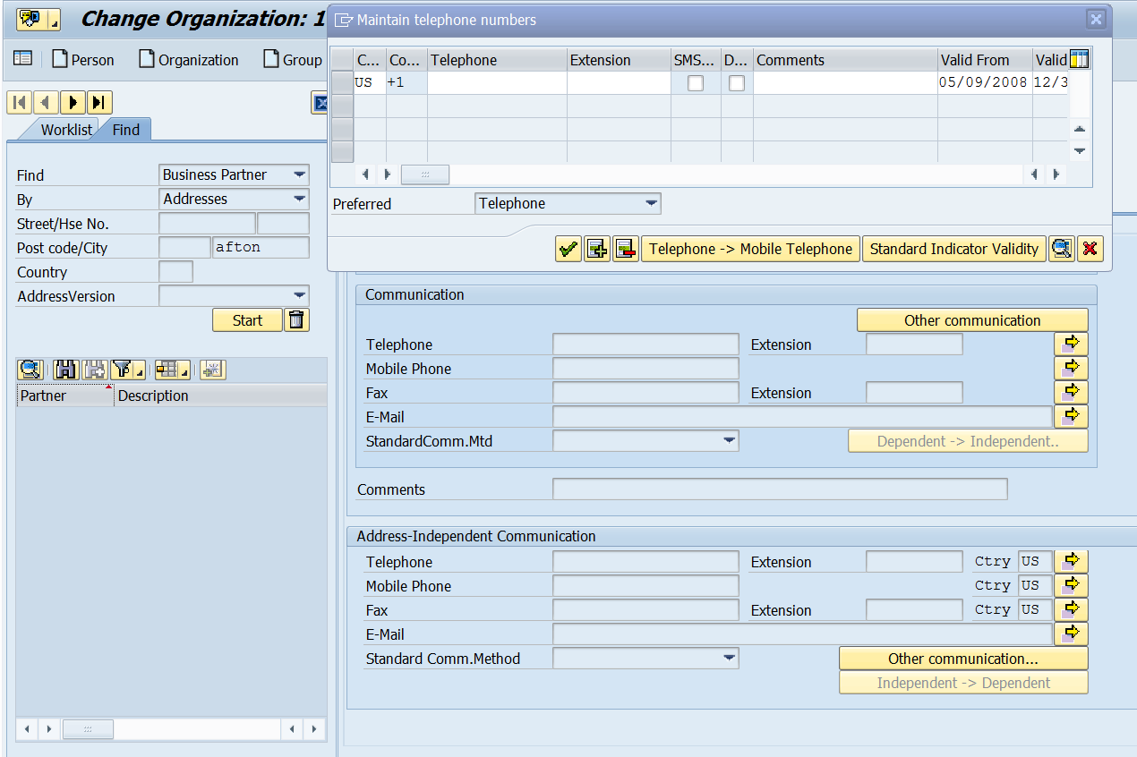

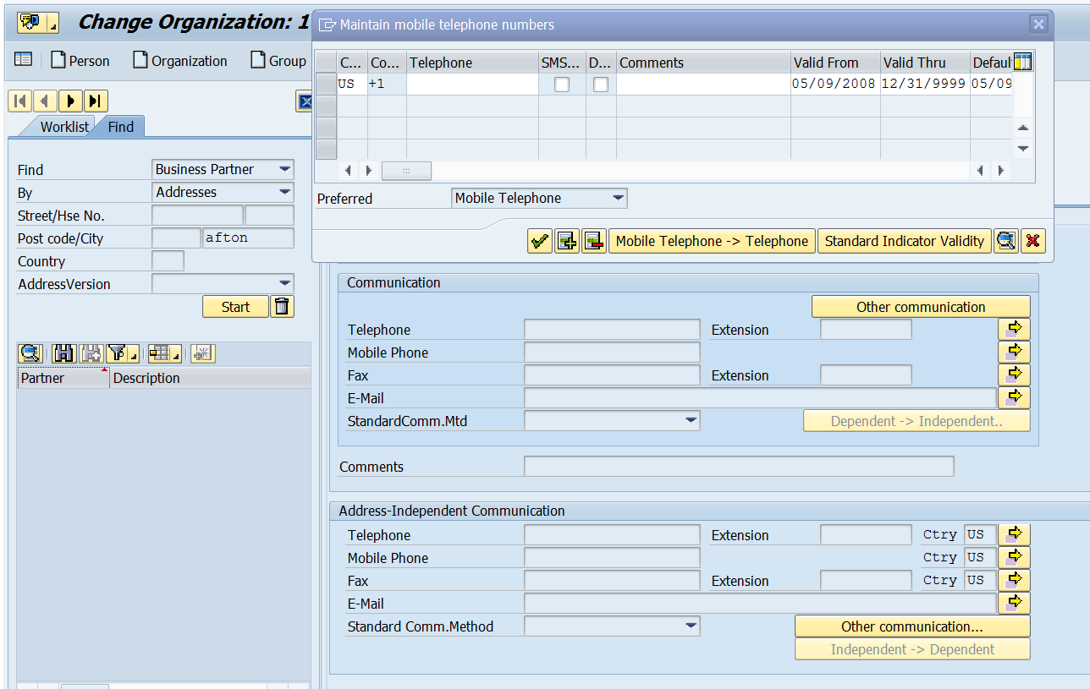

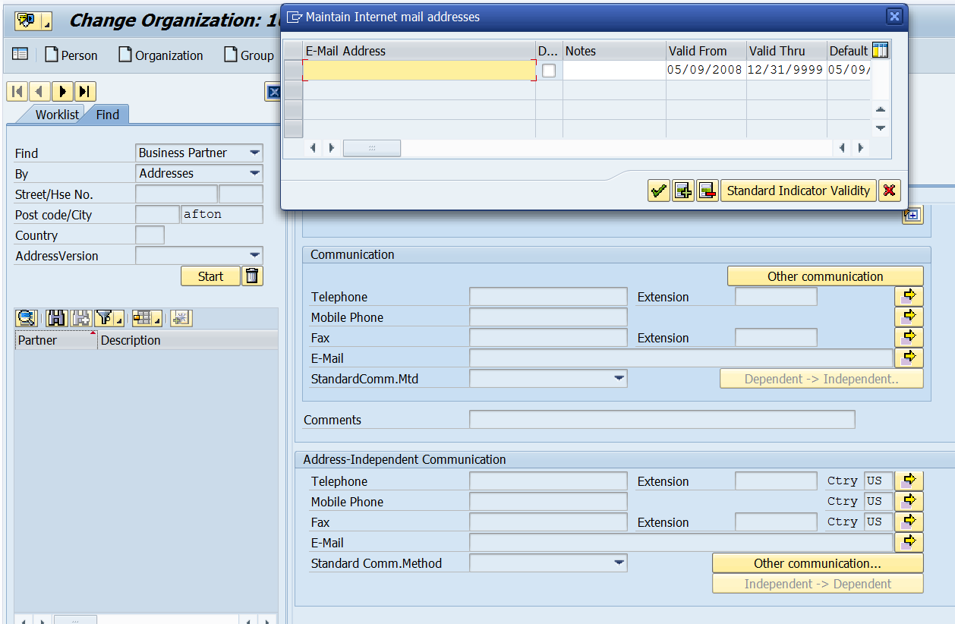

Add below fields for CI-1

Fetch information from Installation
- Rate Category (EANLH-TARIFTYP)
This field will be used to send DPP program information (RS_1007 or RS_1008) for CE initiated Enrollments.
- Device Location Number (DEVLOC) where device is technically installed

Create additional data elements as flags (set, not set)
- Senior Flag (identification type “Primetimers”, if populated). This flag may be set by ESB, based on the IT.
- Senior Flag valid from date
- Senior Flag valid to date
- DLA Exclusion Flag This is for customers with conditions, captured as Identification Types. This flag must be set in the extract or by ESB and the reasons or IT’s must not be sent to DIV or DRMS since, per requirement DDCE-001, these conditions will cause a customer to be considered ineligible for the DLA Programs and all customer data related to customers who fulfill these conditions will be suppressed from the Master File sent to DIV.
The list of relevant conditions should be configurable. The current list of conditions is, as follows:
-Threat of Violence
-Threat of Violence – Dog
-Threat of Violence – Police Escort
-Aggressive Behavior
-Pending theft/fraud/TOV investigation
-APNEA Monitor
-Life Support
-Medical Condition
-Theft
- DLA Exclusion Flag Valid from date (earliest “from” date)
- DLA Exclusion Flag Valid to date (latest “to” date)
- DPP Exclusion Flag This is for customers with conditions, captured as Identification Types. This flag must be set in the extract or by ESB and the reasons or or DRMS , per requirement DPP-038; DPP-039; DPP-042; DPP-016; DPP-062; DPP-134, these conditions will cause a customer to be considered ineligible for the DPP Programs.
Note: This list of conditions should be configurable from a Enrollment Vendor customer segmentation perspective.The current list of conditions are, as follows:
- Pending theft/fraud/TOV investigation
-APNEA Monitor
-Life Support
-Medical Condition
-Theft
New configuration tables will be created which will have Program Type, Descriptions and exclusion types.
- DPP Exclusion Flag Valid from date (earliest “from” date)
- DPP Exclusion Flag Valid to date (latest “to” date
- Do not Market Flag – based on the fields BUT000-ZZBUPINFOREL and BUT000-ZZSOLICIT from CRM. See the screen capture, below:
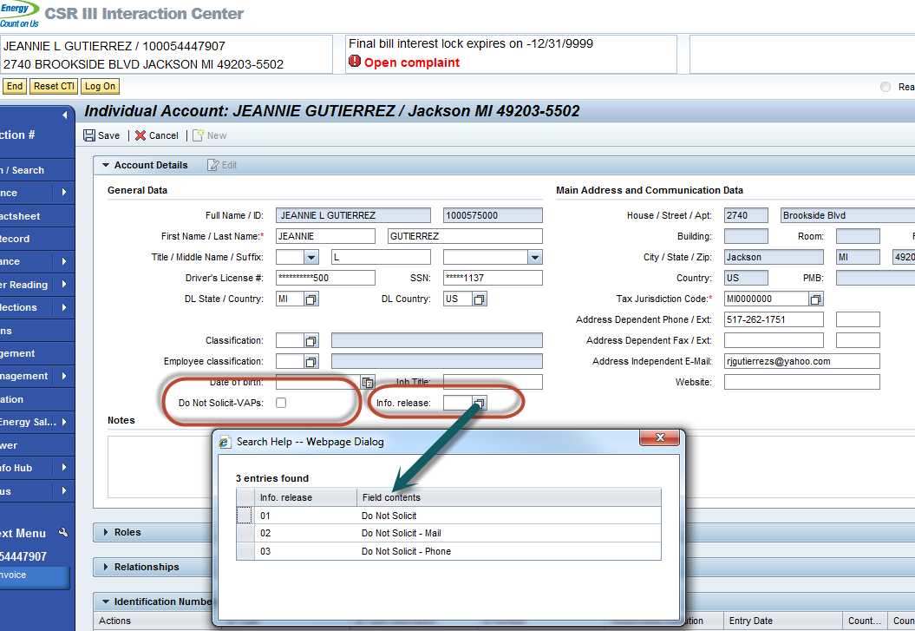

Required fields for DIV and DRMS
- Customer ID – Business Agreement Number (SAP Contract Account)
- Business Partner
- Customer Name,
- Mailing Address – Name and address details for the respective Customer Account.
  - Address number (addrcomm)
  - House number (house_num1)
  - Apt/Suite (house_num2)
  - Street (street)
  - Street 2 (str_suppl1)
  - City (city1)
  - Region/State (region)
  - City postal code (post_code1)
  - Country (country)
- PO Box Address
  - PO Box (po_box) – (Can be blank if there is a standard address)
  - PO Box City (po_box_loc)
  - PO Box Region/State (po_box_reg)
  - PO Box Country (po_box_cty)
  - PO Box Postal Code (post_code2)
- Communication
  - Standard communication method (deflt_comm)
- Phone – The standard phone numbers maintained on the Customer Account will be extracted.
  - Telephone Number
  - Extension
  - Mobile Phone
  - Country
- E-mail – All phone numbers maintained on the Customer Account will be extracted.
  - Email Address
- Senior Flag – Customer identification type “Primetimers”, if populated; will be included
  - Senior Flag
  - Valid from date
  - Valid to date
- Installation ID (ANLAGE)
- Rate Category (EANLH-TARIFTYP) – the Rate at which the customer’s active Electric contract is on.
- Move-In Date – This date is the start date of the Electric Contract.
- Move-out Date – This date is the end date of the Electric Contract. The date will be sent only when a customer moves out.
- DLA Exclusion Flag – In case the customer transitions to a special condition that warrants exclusion from the DLA program, this flag will be updated. All records with this flag Blank or Set, will be sent via the interface. It will be up-to the DIV to determine if an update or create of the master data record required.
  - DLA Exclusion Flag
  - Valid from date
  - Valid to date
- Do not Market Flag
- Device Location Number (DEVLOC) where device is technically installed

Required fields for DPP EV and DRMS

- Customer ID – Business Agreement Number (SAP Contract Account)
- Business Partner
- Customer Name,
- Mailing Address – Name and address details for the respective Customer Account.
  - Address number (addrcomm)
  - House number (house_num1)
  - Apt/Suite (house_num2)
  - Street (street)
  - Street 2 (str_suppl1)
  - City (city1)
  - Region/State (region)
  - City postal code (post_code1)
  - Country (country)
- PO Box Address
  - PO Box (po_box) – (Can be blank if there is a standard address)
  - PO Box City (po_box_loc)
  - PO Box Region/State (po_box_reg)
  - PO Box Country (po_box_cty)
  - PO Box Postal Code (post_code2)
- Communication
  - Standard communication method (deflt_comm)
- Phone – The standard phone numbers maintained on the Customer Account will be extracted.
  - Telephone Number
  - Extension
  - Mobile Phone
  - Country
- E-mail – All phone numbers maintained on the Customer Account will be extracted.
  - Email Address
- Senior Flag – Customer identification type “Primetimers”, if populated; will be included
  - Senior Flag
  - Valid from date
  - Valid to date
- Installation ID (ANLAGE)
- Rate Category (EANLH-TARIFTYP) – the Rate at which the customer’s active Electric contract is on. For DPP this field will be used to Store DPP rate category (RS_1007 or RS_1008)
- Move-In Date – This date is the start date of the Electric Contract.
- Move-out Date – This date is the end date of the Electric Contract. The date will be sent only when a customer moves out.
- DPP Exclusion Flag – In case the customer transitions to a special condition that warrants exclusion from the DPP program, this flag will be updated. All records with this flag Blank or Set, will be sent via the interface. It will be up-to the Enrollment vendor to determine if an update or create of the master data record required.
  - DPP Exclusion Flag
  - Valid from date
  - Valid to date
- Do not Market Flag
- Device Location Number (DEVLOC) where device is technically installed

Expected triggers for the daily “changed data” extract for DIV and DRMS

- Business Partner changes
  - Including DLA Exclusion Flag conditions (identification types) changes
  - Including DPP enclusion flag conditions(identification types) changes
- Contract Account changes
- Contract changes
- Do not Market Flag
  - The source fields are only in CRM, so we will need an event from CRM that will insert a trigger into the trigger z-table ZTMD_OBJ_TRACKNG in SAP
  - If there is a trigger inserted in the trigger z-table, we will need an RFC call to CRM for the flag setting in the extraction
- Enrollment pending updated for CE CSR initiated Enrollments
- Enrollment confirmation update for EV and CE initiated enrollment
- De-Enrollment confirmation update.

Search fields/Variant fields for nightly batch

- BP Number (PARTNER)
- Created on date
- Changed on date
- Contract Number (VERTRAG)
- Contract Account Number (VKONT)
- Number of records per batch job thread (default 1000)

Project / Development Constraints
N/A

Performance Criteria
N/A

Source  System | Destination  System | Performance Requirements for Interfaces
 |  | Average Transactions / Records and Type per Interface Run (include input & output): | Peak Transactions / Records and Type per Interface Run (include input & output): | Required Throughput For Interface (include input & output):
SAP | ESB | ~10,000 - Outbound | TBD | ~10,000 Outbound a day

Other Objects Affected
Program Name = ZMDCSO_BMD_EXTRACT
Transaction Code = ZBMDIWP
Object | Impact/Change Description

SAP System | SAP Module | Impact/Change Description
 | ECC | SAP will need to be configured to support the file transfer

NON-SAP / Legacy System | Impact/Change Description
ESB | ESB will have to be configured to support the BMD file transfer

Dependencies:
Nightly batch job to send the updated BMD to ESB.

External References
Document Title | Author | Attachment / Links
- PJT03247.Interval.Web.Portal.System.Business.Process.Design.doc | Rajnish Kaushik  John Lalicker

Definitions/Acronyms/Abbreviations
IWP – Interval Web Portal
ESB – Enterprise Service Bus
BMD – Business Master Data
DIV – Designated Installation Vendor
DRMS – Demand Response Management System
EV – Enrollment Vendor
DPP – Dynamic peak program
INTERFACE DESIGN SPECIFICATIONS

Detail Requirements:

SAP business master data is required in multiple systems. SAP is required to send the available BMD to ESB. A one time sync followed by a nightly batch run will provide previous day updates and creations to current business master data from SAP to ESB.

Interface Business Object
Business Object | Business Master Data
Business Object Description | BMD will be gathered from multiple tables within SAP and will be sent via an interface to ESB. ESB will format the information and send it to the proper module requesting the data.  There will be a one time sync between SAP and ESB. After the one time sync there will be a nightly batch job to send updated and created BMD.There will be another one time sync is required for the R4C DIV and DRMS integration.  for R5 another one time sync is required for the R5 EV and DRMS integration  Batch Job  Batch job will be setup in Redwood which will be executed post midnight every day. The batch job will include any created or changed BMD for the previous work day.  Manual (if necessary)  Custom TCode will be provided to the user to execute a manual data dump and submit to ESB. A user selected variant will be created to ensure the proper data is being selected. The program will publish the results to the user based on the selection criteria and on the results screen provide option (push button) to submit the data to ESB.

ZPROG_TYPE - Define Program
Field Name | Key | Data Element | Data Type | Length | Description
CLIENT | X | CLNT | CHAR | 3 | Client
ZPROG_TYPE | X | ZPROG_TYPE | CHAR | 6 | Program Type

ZPROG_TYPET - Program Description Table
Field Name | Key | Data Element | Data Type | Length | Description
CLIENT | X | CLNT | CHAR | 3 | Client
SPRAS | X | SPRAS | CHAR | 1 | Program Description
ZPROG_TYPE | X | ZPROG_TYPE | CHAR | 6 | Program Type
DESCRIPTION |  | CRMT_DESCRIPTION | CHAR | 40 | Program Description

ZPROG_EXCLUSION - Define Program Exclusion
Field Name | Key | Data Element | Data Type | Length | Description
CLIENT | X | CLNT | CHAR | 3 | Client
ZPROG_TYPE | X | ZPROG_TYPE | CHAR | 6 | Program Type
ZTYPE | X | BP_ID_TYPE | CHAR | 6 | Exclusion Type
ZEXCLUDE |  | FLAG | CHAR | 1 | DPP Exclusion Flag
ZPROG_UUID |  |  | CHAR | 36 | Program UUID

A two level maintenance view will be created which will facilate Program Manager to define the Exclusion Condition.

Application Name | Source | Destination
SAP ERP
ESB
< List Application Name1>

Source Application Interface Type(Check one Only)
Screen
Report
File
Database Table
Application Protocol Interface (API)
Other (Describe)

Destination Application Interface Type(Check one Only)
Screen
Report
File
Database Table
Application Protocol Interface (API)
Other (Describe)

Legacy Systems | Contact Name
< Source System Name & Description > | <Provide contact name and info for each system >
Source 1
Source 2

Method of Execution:  (Foreground / Background Scheduled / Manual / On Demand) | Background scheduled
Inbound / Outbound: | Outbound from SAP

Selection Criteria/Screen
Field Name | Selection Text / Description | Type of Field (Check Box / Radio Button / Select-Option / Parameter) | Search Help / Pick List / List of values  (Y / N) | Validation Required  (Y / N) | Default Value | Comments  (Mandatory / Optional) | Single/Multiple/Range/all possible combinations
CRDAT/ERDAT | Created on date | Option | Y | Y |  | Mandatory | All Possible
CHDAT/AEDATP/AEDAT | Changed on date | Option | Y | Y |  | Mandatory | All Possible
PARTNER | BP Number | Option | Y | Y |  | Mandatory | All Possible
VKONT | Contract Account Number | Option | Y | Y |  | Mandatory | All Possible
VERTRAG | Contract Number | Option | Y | Y |  | Mandatory | All Possible

Detailed Data Mapping

The one time sync will be a BMD dump from ECC to ESB. Following the dump the nightly batch run will include any created or changed BMD for the previous day. The nightly batch program will need to reference the following data triggers to select the correct BMD. A variant should be created for a user to select which will include the following data elements;
- BP Number (PARTNER)
- Created on date
- Changed on date
- Contract Number (VERTRAG)
- Contract Account Number (VKONT)
- Number of records per batch job thread (default 1000)

If one of these elements meets the critera then all the required fields from SAP will need to be sent to ESB for each account meeting the criteria. The change documents can be used to extract the required data.
Example, If business partner data is created/changed, send all that BP information to ESB.

Source System Data Profiling
N/A
Destination System Data Profiling
N/A
Processing Specifications for Middleware
N/A
Processing Business Rules for the Middleware
<Describe the processing business rules for middleware in addition to what has been specified in the mapping document. This section can be used
- To reference the rules when warning/informational notifications need to be sent
- To specify data filter criteria for the dataset being processed
- Any sort/grouping requirement.>

DLA Exclusion Flag – If this flag is not created during extract, it must be created by ESB for the DIV. Only the flag can be sent to DIV since, per requirement DDCE-001, these conditions will cause a customer to be considered ineligible for the DLA Programs and all customer data related to customers who fulfill these conditions will be suppressed from the Master File sent to DIV.

Customer data eligibility (selection) criteria
For DIV:
- Include: Customers with active Electric service contracts
- Exclude: Customers with Gas only service contracts. This exclusion does not apply to customers with combo services.

For DRMS: Customer data extract to DRMS is contingent upon completed DLA enrollment. The SAP system determines positive DLA enrollment at the time the Electric service is switched to a DLA Rate Category. Specifically, the RS_1005 and GS_1005 rate categories can be used as criteria by ESB, to select the BMD for routing to DRMS.
DPPExclusion Flag – This flag will be created during extract for the EV. Only the flag can be sent to EV since, per requirement DPP-038; DPP-039; DPP-042; DPP-016; DPP-062; DPP-134, these conditions will cause a customer to be considered ineligible for the DPP Programs..If there are multiple ID Type which are still valid; the start Date will be selected as earliest and later for the End Date.

Customer data eligibility (selection) criteria
For EV:
- Include:
  - Customers with active Electric service contracts
  - Residental Customers
  - Customer having Smart Meter installed at their Permise
- Exclude:
  - Customers with Gas only service contracts. This exclusion does not apply to customers with combo services.

For DRMS:
Enrollment
- Customer data extract to DRMS is contingent upon completed DPPenrollment. The SAP system determines positive DPP enrollment at the time the Electric service is switched to a DPP Rate Category. Specifically, the RS_1007(CPP) and RS_1008(PTR) rate categories can be used as criteria by ESB, to select the BMD for routing to DRMS.

Scheduling Requirements for this Interface
Rule | How is this Interface initiated or triggered? | What is the Initiation or Trigger Source? | How frequently is this Interface run? | What days of the week does this Interface get run? | What time of the day is this Interface run & what is the allowed time window? | What are the Load Balancing or Parallel Processing considerations? | Is this Interface Synchronous or Asynchronous? | What are the predecessor processes & dependencies for this Interface?
Description | BMD Interface will run nightly. This interface can be triggered manually if needed. | Time based | Once daily/Manual if needed | Everyday | Nightly during batch | N/A | Asynchronous | N/A
Source 1
Source 2
Source n
Scheduling Requirements

File Descriptions (if applicable)
N/A
Input File Requirements for Inbound Integrations (if applicable)
Information Needed | Logical File Name | File Description | Variants | System Name | Physical File Location & Name | Selection Requirements | Empty Files | Sort Order For Incoming File / Message | Length of Time to Archive the Source File
Description | < Name file is commonly known by> | < Description of type and purpose of the file> | <Variants in Logical File Name if used> | <System the file is associated with > | <Name and directory path of file > | < Selection criteria if required> | < Are empty files to be expected/permitted as part of normal processing?> | <list of columns for the default sort order and indication on ascending or descending for each column> | <X Days, Months, Years, etc.>
Source 1
Source 2
Source n

Output File Requirements for Outbound Interfaces (if applicable)
Information Needed | Logical File Name | File Description | Variants | System Name | Physical File Location & Name | Selection Requirements | Empty Files | Sort Order For Incoming File / Message | Length of Time to Archive the Client File
Description | < Name file is commonly known by> | < Description of type and purpose of the file> | <Variants in Logical File Name if used> | <System the file is associated with > | <Name and directory path of file > | < Selection criteria if required> | < Are empty files to be expected/permitted as part of normal processing?> | <list of columns for the default sort order and indication on ascending or descending for each column> | <X Days, Months, Years, etc.>
Source 1
Source 2
Source n

Architecture Specifications

Generic Interface Pattern
Point-to-Point
Publish-Subscribe | X
Request-Reply
Fire and Forget
Other (Add Description)

Interface Type
Real-Time Synchronous
Real-Time Asynchronous
Batch | X

Messaging Standard
none
ebXML | X
RosettaNet
Ariba Supplier Network (ASN)
AS1
AS2
xCBL
ChemXML
OAG
Other (Describe)

Proposed Interface Usage Pattern
Description:
The project team should have an inventory of interface usage patterns that can be re-used for new interfaces. The solution team should review this list and determine if this interface is a new interface usage pattern or can leverage an existing interface usage pattern.

Interface Usage Pattern | New or Existing

Architecture Principles
N/A

Guiding Principle or Guideline Description | Rationale

Error Handling

Failure Points
Possible Point Of Failure | Rules For Handling Failure
Batch run | “Write error to error log and continue processing.”  A user can kick off a manual run.
Data Input Validation on the screen | Display Validation error message for the Data Element. e. g. Date Range entered and request input of correct date range. The Start Date Range cannot be greater than the End Date.
Data Validation of the file/message, when it is picked up by Middleware. | Capture the transaction record having the data validation error and log it in an error report. Also capture the key fields identifying the record and the offending data element with relevant message describing the error. The Error Report needs to be sent via an email alert. The Source system should fix the transaction file/message and resend the file/message.
Mapping and Transformation Error | Send an email alert for the offending message to the Interface Support team. The Interface Support Analyst would need to analyze and identify and recommend resolution.
Business Rule Validation and Application Logic Processing Error | Flag the transaction record in the staging table to be an “Application Error” and display an error message indicating type of error, with recommended fix if possible. A notification needs to be sent with the list of transactions that are in error and the type of error for each transaction. The user should be able to review the transaction make necessary correction, and be able to resubmit transaction for processing.
Cross Reference Error | Flag the transaction record to be an “Application Error” of type X-REF Error and send email notification. The notification should list the data elements with missing cross reference and guide user to update the Xref Master table. The transactions in error need to be reprocessed upon initiation by the user, after the Cross Reference Master has been updated

Error Report Requirements
Information Needed | Description
Error Logging (beyond notification) | <Identify how/where errors are to be logged>  Errors will be logged in a Monitoring Console
Error Remediation | <Identify what procedures are required to clear the error and (if applicable) resubmit/re-run? There must be an associated FDD/MFDD listed.>

Error Notification
Application Errors
Description | Notification Reqd  <Yes/No> | Type of Notification  (Outlook Inbox, SAP Inbox) | Business Recipients: Email Group Names | Systems Operations and Support Recipients: Email Group Name
Error Notification that are raised by Destination Application interface | Yes | Outlook | Smart Energy Po Box

System Errors
Description | Notification Reqd  <Yes/No> | Type of Notification  (Outlook Inbox, SAP Inbox) | Business Recipients: Email Group Names | Systems Operations and Support Recipients: Email Group Name
Error Notification on job abend | Yes
Notification if job start time is delayed by < 1 hours > from acceptable timeline | Yes | Outlook | Smart Energy PO Box
Notification if job processing time is delayed by < 1 hours > from acceptable scheduled end time | Yes | Outlook | Smart Energy PO Box

Note if you need to provide a Report for Errors, then refer to the Functional Specs for “Reports” and document it as a new PRICEFW in the PRICEFW Tracker.

Post Execution Notification Details
N/A

Process Log Details
After the nightly batch run the results should be published in ALV format and should be capable for download in excel format.

ADDITIONAL INFORMATION

Unit Test Plan

Identify the Test Scenario to be used to test the development with:

Test Considerations | Scope of Testing (Inside SAP (IS) / Outside SAP (OS) / Both (BO)) | Target Test Date
 |  | MM-DD-YY

Related Business Scenario and Business Transactions

Test Data
Test Data needs to be provided for the unit test scenarios and should be planned for in the workplan. For files, embed a small subset of the data structure containing data.

Interface Recovery
Description:
Identify any business need or requirements in recovering the interface transactions. Interfaces are typically addressed by IT Operations. This section is being provided if there is a business specific requirement needed for recovery. For this Functional Specification, identify any unique recovery needs for the interface, specifically with respect to the data files being used. Standard practice is to retain at least 5 days of data files to be used for recovery. If there is a business requirement to retain data files beyond 5 days please specify here. If there are unique data retention requirements regarding interface feeds from/to external 3rd party system please advise.

Information Security
Description:
IT Security will review the information contained within this specification and lead security requirements implementation with the solution teams and technology. Classification is based on Client’s Information Security & Compliance Standards.

Note: This section should be aligned with the Source and Destination SAP Interface FSPECs.

3.2.1Information Classification

General Information
Businesses Impacted:
Information Classified by whom: |  |  |  |  |  |  |  |  | Date

Contact Information
 | Company |  |  | Name |  |  | Phone |  |  |  | E-mail Address
List Potential
Information Owners:

Architecture
Environments: (impacted by this Fspec): |  |  |  | Development Test Training Production
Architecture: (system exposure): |  |  |  | Public (Internet) Facing Internal Only  3rd Party Hosted Company * Hosted

Identity & Access Management
During Project  3rd party system access required? |  |  | Yes  No | Offshore? |  | Yes  No |  | List the 3rd Parties:
Post Implementation  3rd party system access required? |  |  | Yes  No | Offshore? |  | Yes  No |  | List the 3rd Parties:

Business Impact Analysis
What may be impacted if the system or information/data is compromised? Check all that may apply.
Brand Reputation/Trust  Associate Relations  Competitive Advantage  Financial Impact  Productivity  Supply Chain  Contractual (i.e. NDA’s, MSA’s) |  |  |  |  | Regulatory  Compliance  Securities & Exchange Commission (SEC)  Payment Card Industry (PCI)  Sarbanes-Oxley (SOX)  Privacy Laws
Input any additional details related to business impact in the event of compromise:

Information Classification
Action #1: Check the box below that represents the most restrictive classification.
Action #2: If Level 1 or 2 is selected, check the box below indicating data storage or data transmission.

See “Information Classification, Labelling and Handling” in Client’s ISC Standards for details on the formal classifications and data handling standards.

Level 1 – Confidential – Secure Handling Required “SHR”

Confidential – Secure Handling Required represents the most sensitive data classification related to individual personal identifiable information and personal financial account information. This information considered critical to Client such that, if disclosed, may disrupt or impede business operations, and due to legal, reputational, or operational concerns, requires additional security controls. Information in this category includes, but is not limited to:
1. Social Security Number
2. Driver’s License Number or Government-issued Identification Number
3. Financial Account Number (card number or personal bank number)
4. Protected Health Information & Electronic Protected Health Information

SHR data stored? SHR data transmitted? SHR data stored and transmitted?

Level 2 – Confidential

Confidential represents the second most sensitive data classification related to operationally significant business information. This information considered critical to Client such that, if disclosed, may disrupt or impede business operations. Examples of Restricted Confidential include but are not limited to regulatory governed data, trade secrets, mergers and acquisition discussions, product formulas and designs, corporate earnings data prior to public announcements, reorganization details prior to announcements, current/closed company investigations and litigation, detailed network diagrams that could jeopardize network security, strategic development/marketing plans and information integral to the success and operations of the company.

Confidential data stored? Confidential data transmitted? Confidential data stored and transmitted?

Level 3 – Internal Client Use Only

Internal Client Use Only represents the third most data. It represents information that is less critical to privacy and business operations but still must not be publicly disclosed. This information is not approved for general circulation outside Client.

Level 4 – Public

Public represents information that has been declared public knowledge by the information owner and can freely be given to anyone without any possible impact to Client. As a result, no special data handling protections are required.

3.2.2 Security Roles (Profiles and Authorizations)
A custom Tcode will be created and will require a new security role for a user to manually execute the nightly batch job if necessary

Security Requirements for Interfaces
Security Type | Role | Access Allowed
Authority to Request Interface | <FDD Role 1>  <FDD Role 2> | <Roles allowed to request the Interface or “N/A” if automatically requested>
Authority to View Interface Files | <FDD Role 1>  <FDD Role 2> | <Roles allowed to receive the Interface>
Authority to View Error Report | <FDD Role 1>  <FDD Role 2> | <Roles allowed to receive the Error Report>
Field Level Security | <FDD Role 1>  <FDD Role 2> | <Any restrictions on the fields on the Interface that individuals with this role can either see>
Data Security | <FDD Role 1>  <FDD Role 2> | <Any restrictions on the data that someone with this role can either see and/or update>

This section should define the security requirements for this design.
Once all required security checks have been incorporated into the ABAP/4 program, they must be tested and signed off by the Security Administration.

3.2.2.1 Table Security (if applicable)
If new table needs to be created to support the business application, the custom table need to be assigned to authorization group for access protect. Please work with Security team to get the proper authorization group information.
Custom Table | Authorization Group
ZPROG_ID
ZPROD_IDT
ZPROG_EXCLUSION

3.2.2.2 ABAP Program Security (if applicable)
The two different types of authorisation checks used to ensure appropriate data security are:
Value
Authorization Group Check
Authorization Check
Specify what transaction code should be assigned to users so that they can execute this Workflow.
Transaction Code

Define by Process Step, which Business Process Roles will be required to execute this Workflow.
Process Step | Business Process Role

If data access or functionality should be controlled via authorizations, please describe the restriction requirement for each data set or functionality in the table below.
Data set / Functionality | Describe what authorization a User must be assigned to access the data set or functionality

Audit / Control
This section should define any Audit/Control solution for this design, as well as an approach for data verification.

If the Audit / Control requirements for the Application Interface design are defined in subsequent FSPEC’s, these FSPEC’s should be referenced here. If there is a requirement above and beyond the designed Audit Requirement, please define this here.

Audit Trail Requirements
Audit Event | Description | Audit Trail Updates
<Event which causes the need for an audit trail; e.g., data is changed> | <Description> | <Audit message / fields audited>

Audit / Data Integrity Logic
Refer to Audit Control FSPECs. If additional requirements are needed, please document here. Include a list of fields which are needed to validate the integrity of the interface.

Questions / Issues / Risks

Questions/Issues/Risks
Asked By | Question/Issue/Risks | Resolution | Resolution Date

